**ATTACHMENT A**

**Example Certificate Numbering, Roster Spreadsheet, Completion Instructions**

After completion of a CQM-C course, instructor will send the completed spreadsheet to the District CQM Course Manager. The District CQM Course Manager will send the spreadsheet to the Division CQM Course Manager who will update the HQUSACE CQM SharePoint site.

A certificate number will be added to each certificate based on the issuing organization. The certificate number includes the issuing organization i.e. Corps District or NAVFAC Office identifier (three (3) digit field), facilitator identification number (two (2) digit field), current FY (two (2) digit field) and student number (five (5) digit field).

Examples: NWO041101250; SE9041100001 = Organization-district identifier (3 digits);facilitator identifier (2 digits); FY (2 digits); student number (5 digits). Drop down boxes of accepted issuing organizational Identifier codes and two-digit FY are on the Excel spreadsheet located on the HQUSACE CQM SharePoint site. See below for in-depth examples (examples only – may not be the actual number assignment):

District Identifier: Omaha District = NWO

Facilitator Identifier:

00 – Omaha District

01 – Wisconsin Area Office (by office)

02 – Nebraska Area Office

03 – South Dakota Area Office

04 – North Dakota Area Office

05 – Jennifer McQueen (by facilitator name)

Certificate number: NWO042101250=Omaha District/North Dakota Area Office/FY21/number student (01250)

NAVFAC SE = SE9

00 – NAVFAC SE

01 – Facilitator Bruce Pastorini

02 – Facilitator Robert "Whit" Heffington

03 – Facilitator Mark N. Clark

04 – Facilitator John Parker

05 – Not assigned at this time

06 – Not assigned at this time

Certificate number: SE9042100001 = NAVFAC John Parker/FY21/number student (00001)

**A-1**

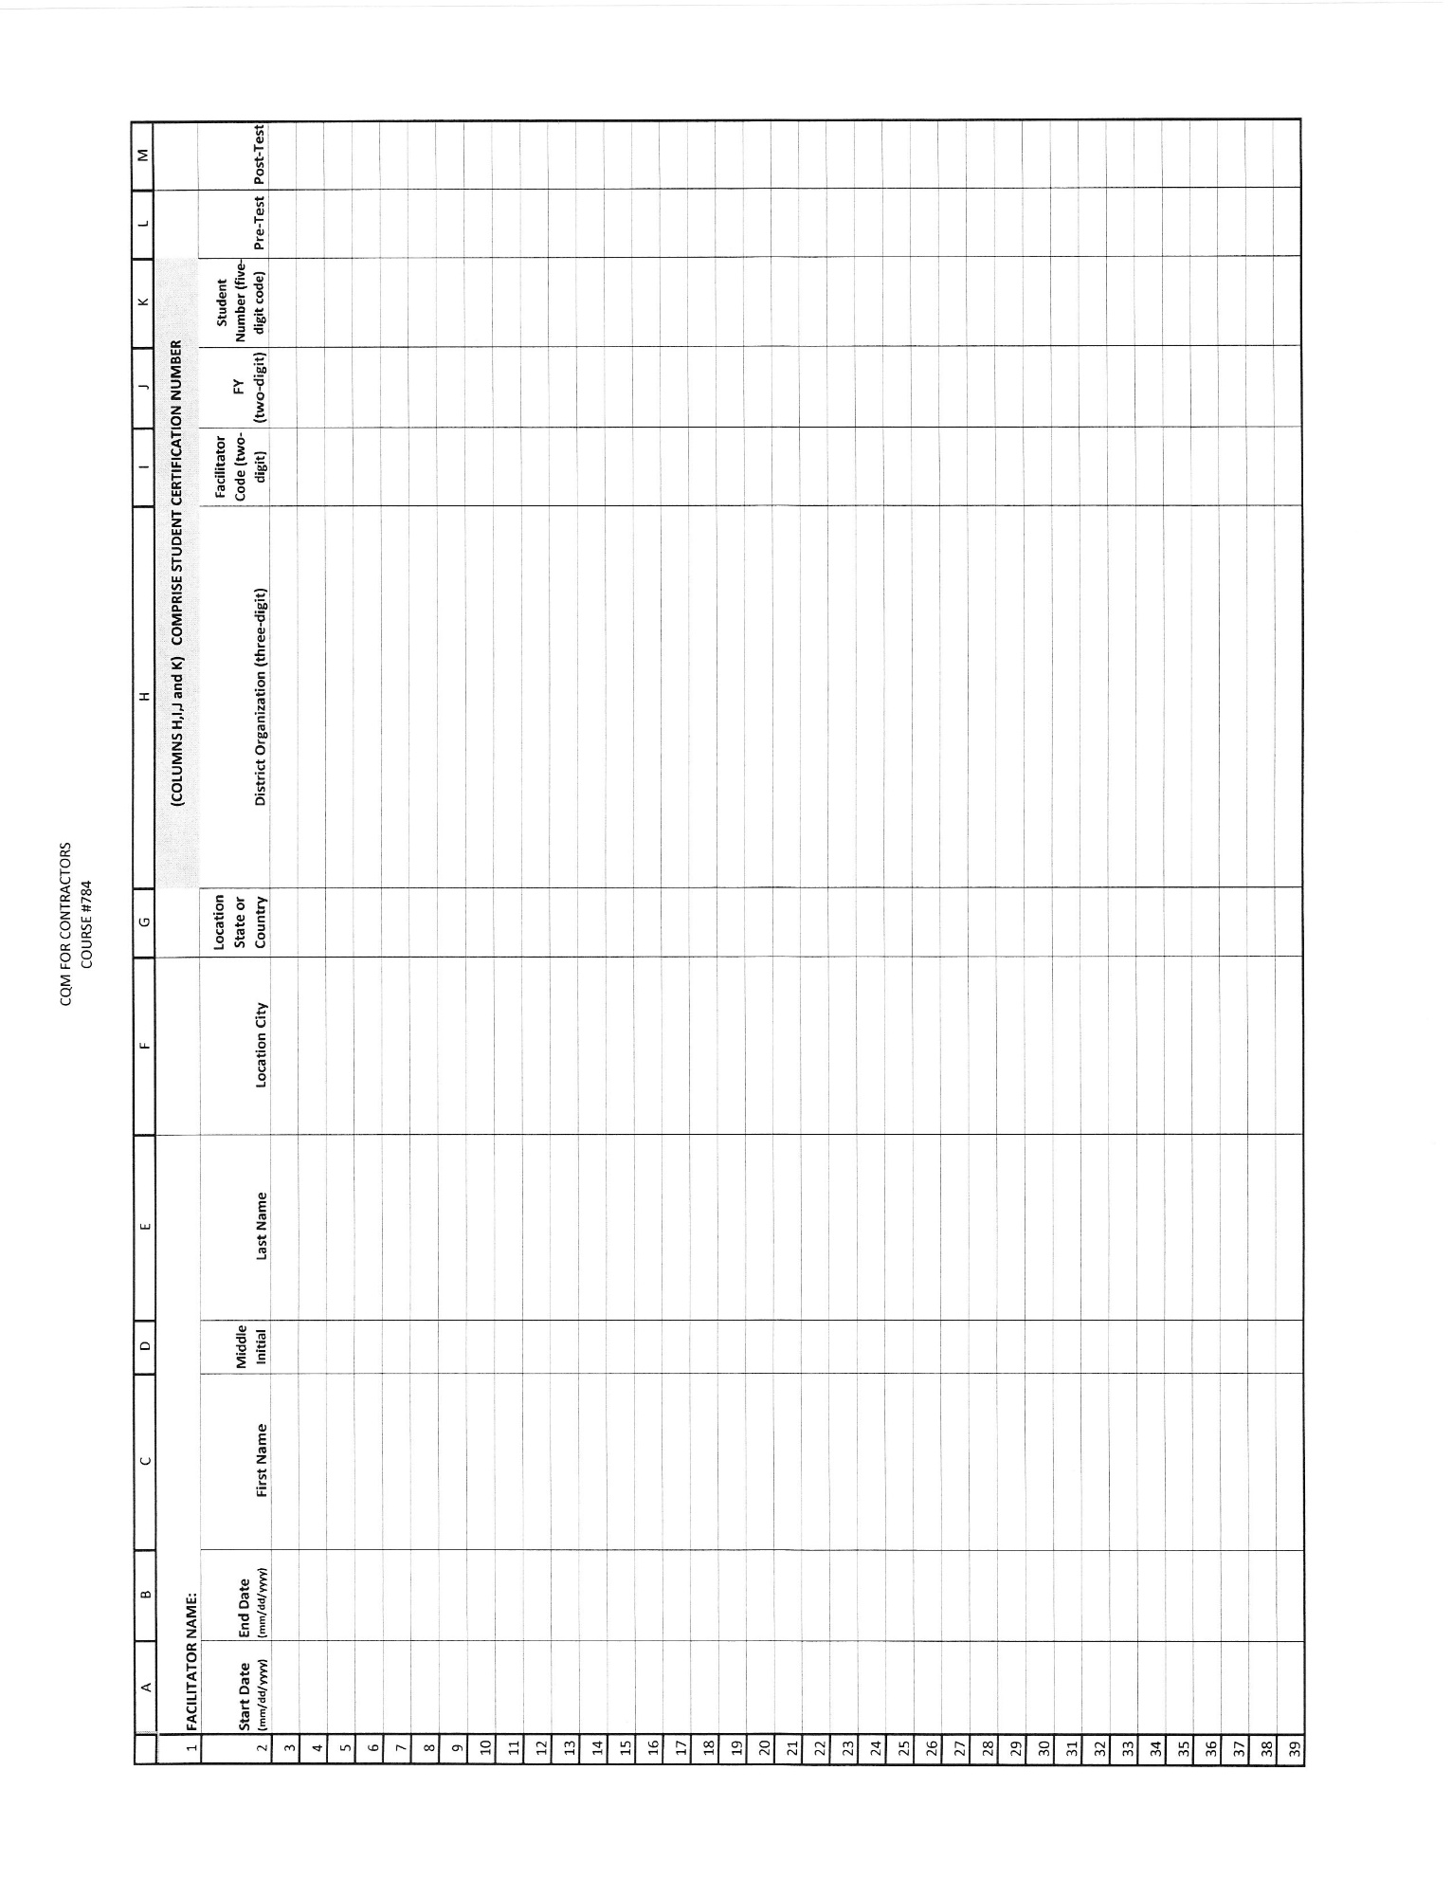

**A-2**

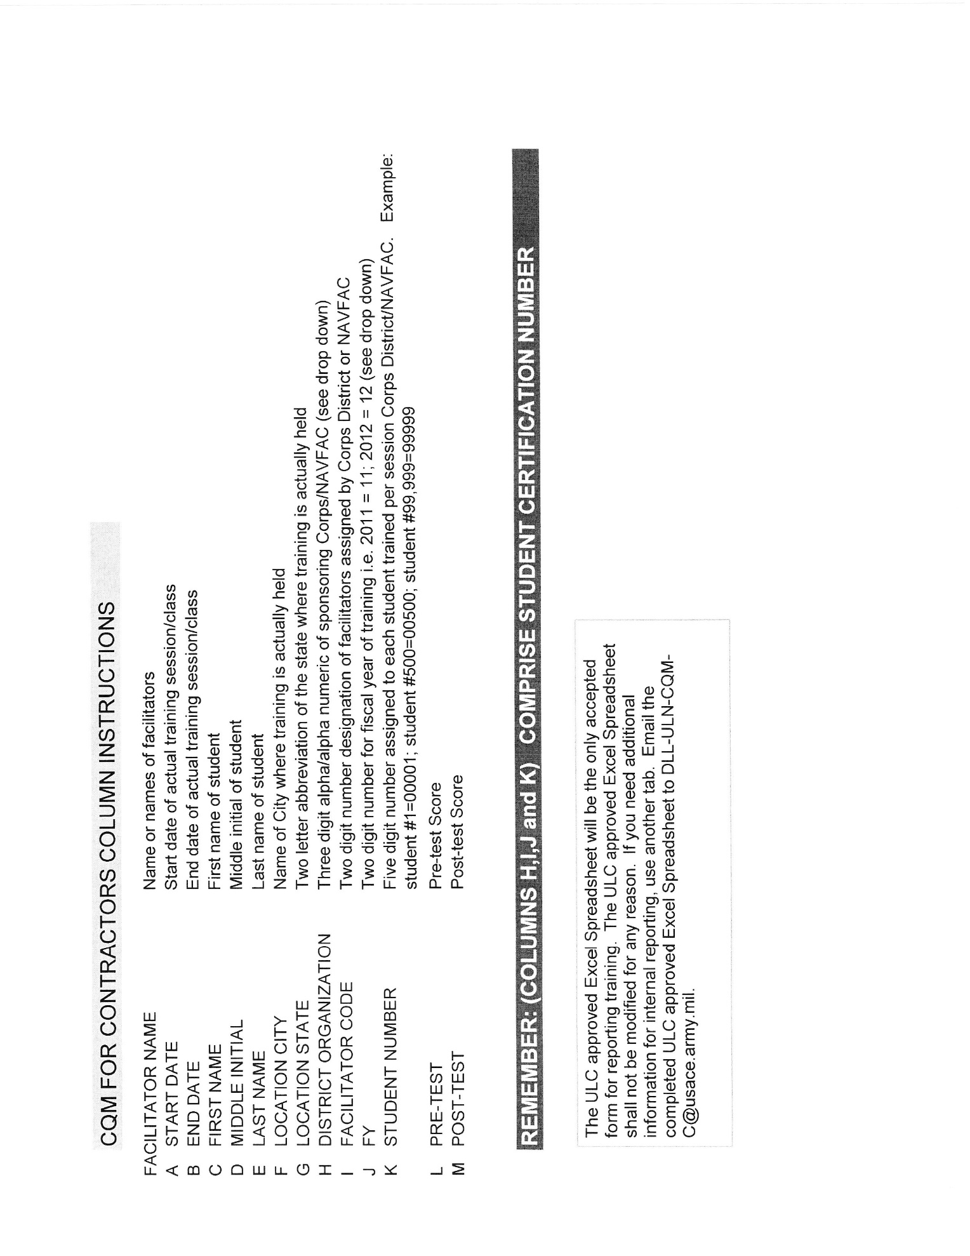

**A-3**